
5-10 Bury Street
London EC3A 5AT

TEL:0207 929 3400 FAX: 0207 929 3600
EMAIL: john.tester@bannermanrendell.com
WEB: www.bannermanrendell.com

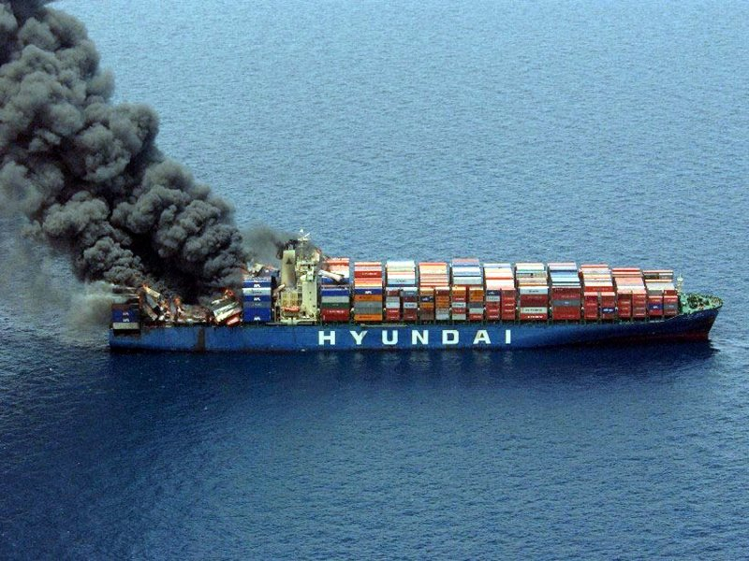

CARGO & STOCK PROPOSAL

For
Importers and Exporters of Cargo

Seamless Marine Cargo and Stock coverage fully supported by expert claims handling and recovery advice.
All in a clear, comprehensive form

If you would like a quotation, please complete the questions in the red boxes (they expand as you complete
them) and click on the reply button on your email toolbar. Please complete the form as fully as possible making sure that you provide sufficient contact information. If the questions do not exactly fit the business profile or if there is insufficient space, use the "Other information" box at the end of the form

1) Company name / address [ ]

Post code [ ] Tel [ ] Fax [ ] Email [ ]

Contact name [ ]

Annual sales [ ] (State currency)

2) Describe merchandise to be insured split between (where possible please base values on intended
sales price) : -

a) FOB/CFR Purchases or similar where you are responsible to insure [ ]

b) CIF/Delivered Purchases or similar, contingency insurance [ ]

3) Annual value of transits wholly within the country of the proposed insured [ ] i.e. UK only

4) Annual value of international transits. Ensure that all voyages are declared and if space is insufficient, use the "Other information" box at the end of this form

From [ ] To [ ] Annual value [ ]

From [ ] To [ ] Annual value [ ]

From [ ] To [ ] Annual value [ ]

From [ ] To [ ] Annual value [ ]

5) Maximum value on any conveyance [ ]

2……..

6) Storage of merchandise.

Location 1 address [ ] Post code [ ]

Maximum value of merchandise [ ]

Location 2 address [ ] Post code [ ]

Maximum value of merchandise [ ]

Location 3 address [ ] Post code [ ]

Maximum value of merchandise [ ]

Location 4 address [ ] Post code [ ]

Maximum value of merchandise [ ]

7) Total claims for last 5 years (if possible) for: - Transit [ ] Storage [ ]

8) If you would prefer an excess to be deducted from claims, state amount here [ ]

9) Other information material and relevant to enable Insurers to assess the risk [ ]

